- Create a bash script to check if a directory is available or not.
IF -else scripting
Creative a file vi is.script and write script
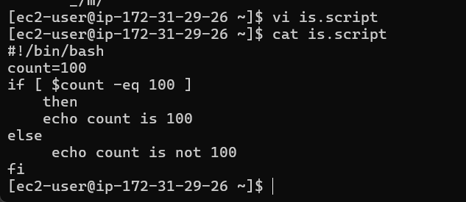
Change permissions to chmod 755 to is.script
And execute
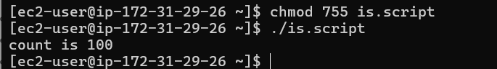
ANOTHER EXAMPLE
Create file
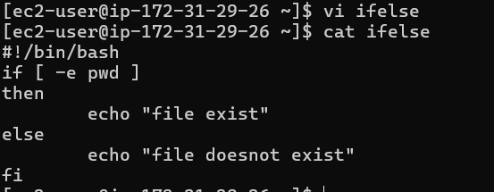
Give permissions chmod 755
And execute
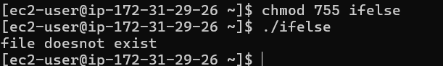
- Create a bash script to create multiple files.
Create file
And write the script
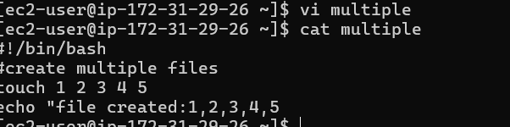
Give permissions
And execure
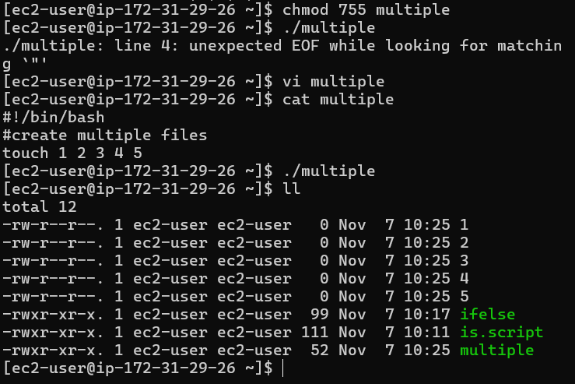

- Create a bash script to take a backup of a directory.
Create backup file
Write script
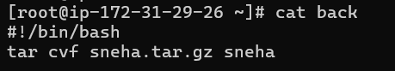
Give permissions
Execute
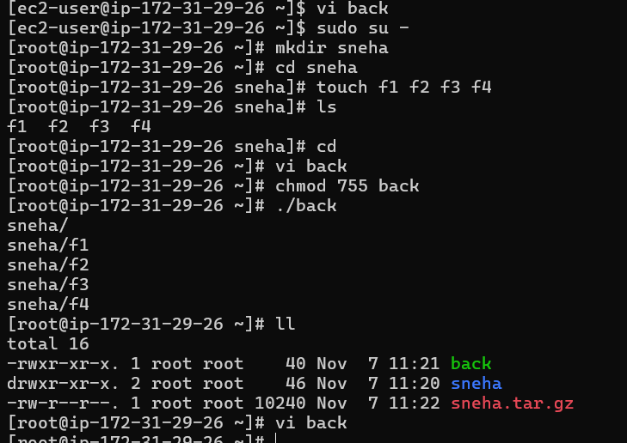

- Create a bash script to install Nginx on an EC2 server.
i
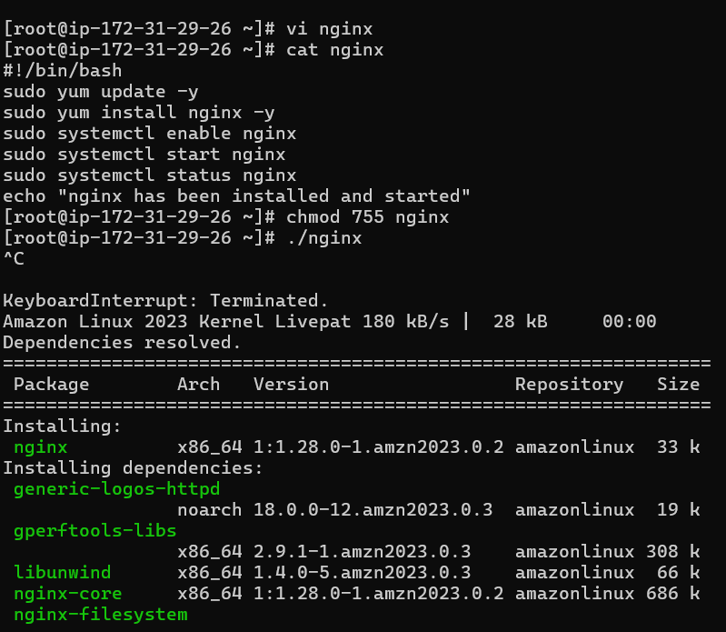
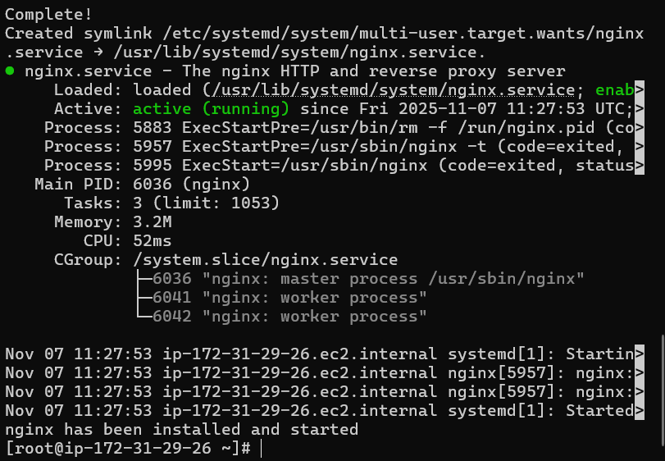

- Create a bash script to install Apache Tomcat on an EC2 server.
Create a file and write the script
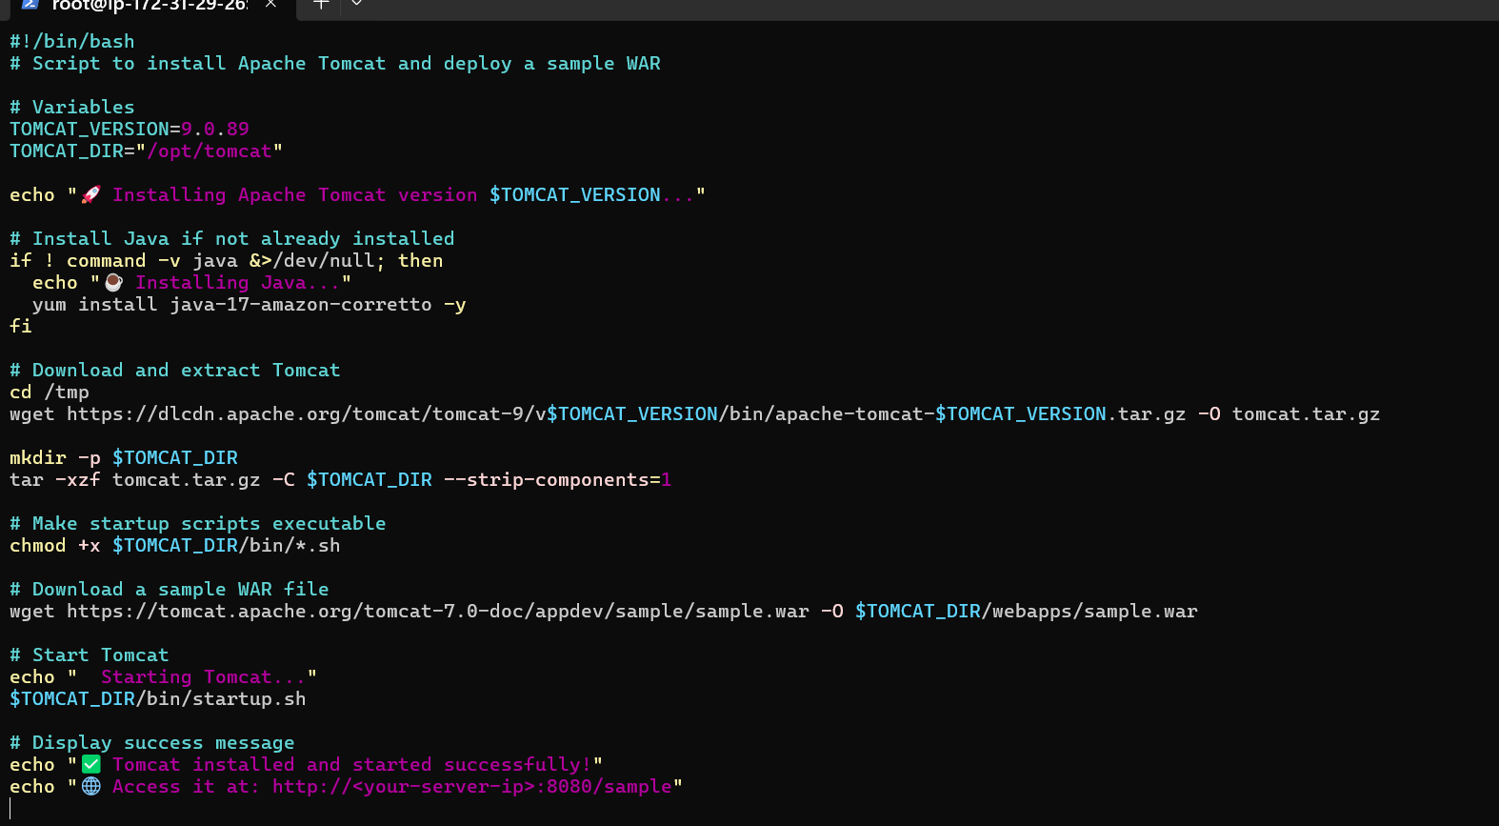
Done with parmissions
And executed
Apache in installed
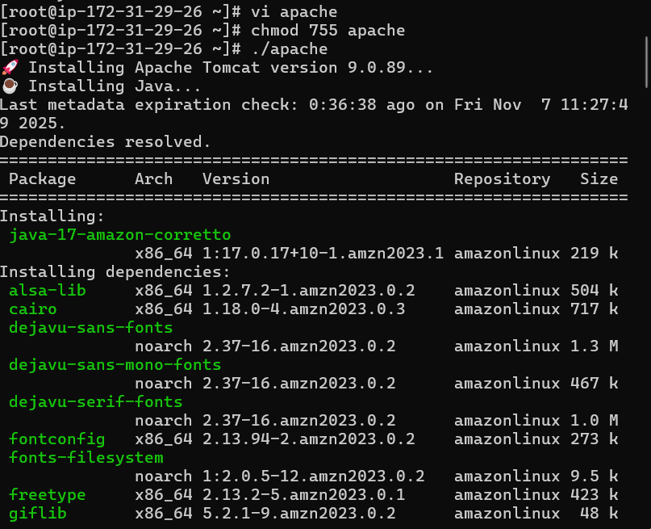
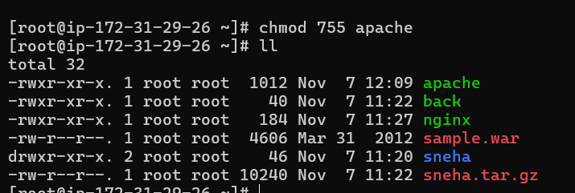
- Create a bash script to check if the Nginx service is running, if not running then script should start the service.
Nginx server running
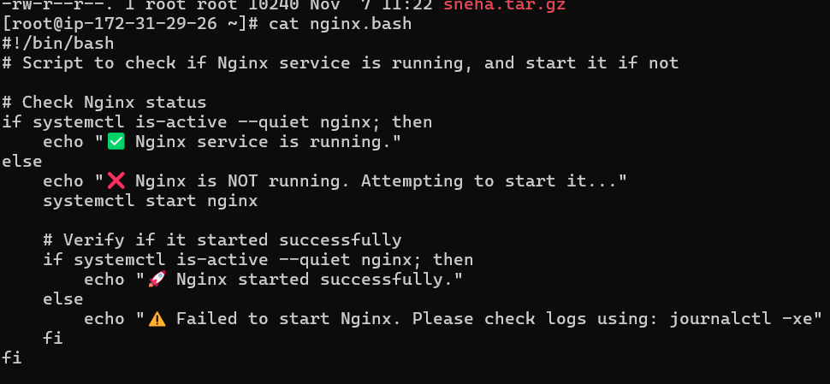
Nginx permissions
Server is running
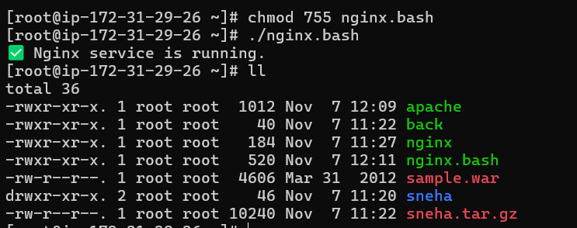
- Create a bash script for a calculator.
Bash script of calander
And permissions
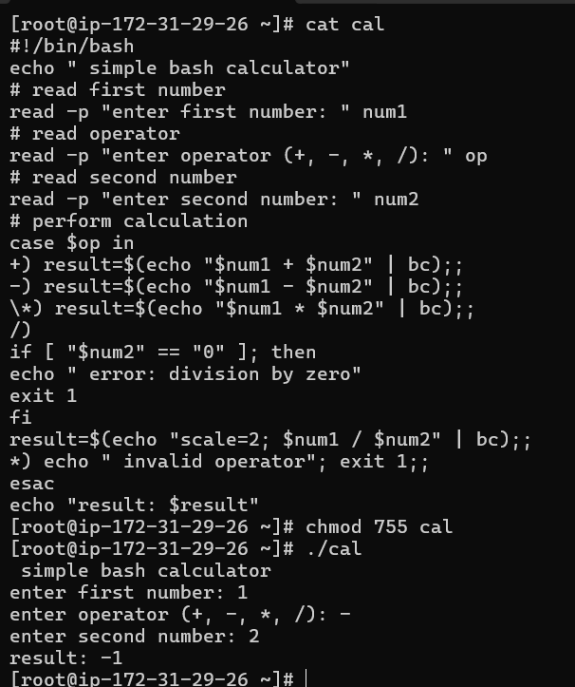

- Create a bash script to check if a directory exists, if not then create a directory.
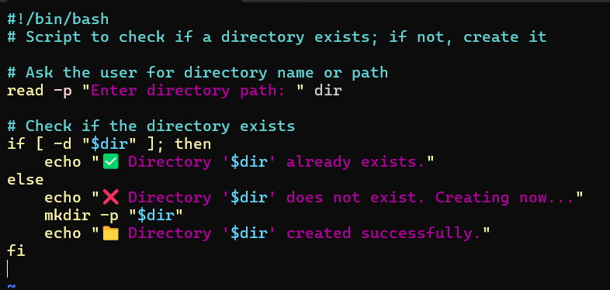
Give permisiions
Execute
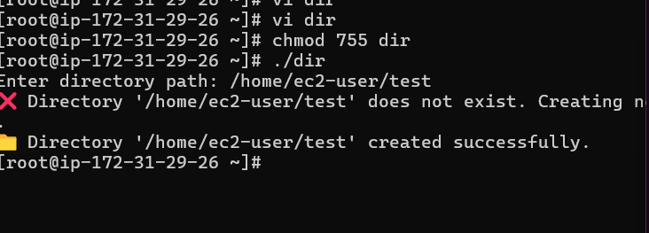

- Create a bash script to delete the last 3 lines of a file.
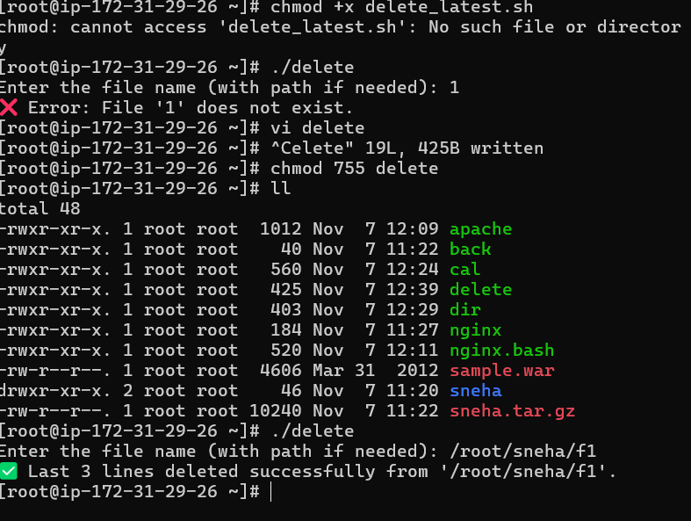
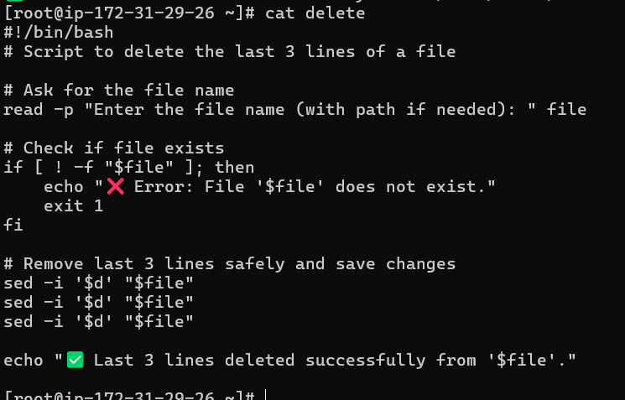

- Bash script to monitor cpu and if it is more than 80% then send email notification.
Donw with permissions
And executes
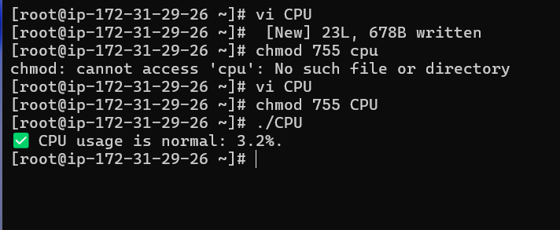
- Bash script to monitor disk space and if it is more than 80% then send email notification.
Dn with permissions
Executed successfully
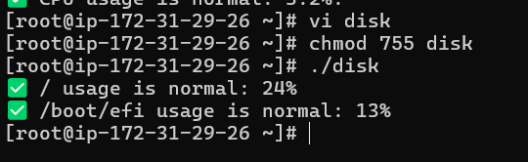
- Bash script to monitor memory and if it is more than 80% then send email notification.
Done with permissions
Executed successfully
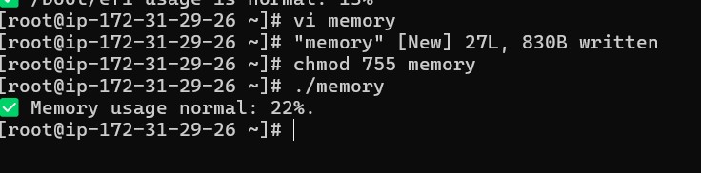

CRONTAB
- April 5th Midnigh
- 5th of Every November, January, June if it is a Thursday
- At 05 and 27th minutes of 9, 10, 11 hours every day
- 34 minutes of 9th hour on 15th August
- Every midnight
- Every Weekend (Saturday night 11:59 PM)
- After every reboot
